1. What are three conclusions we can make about Kickstarter campaigns given the provided data?

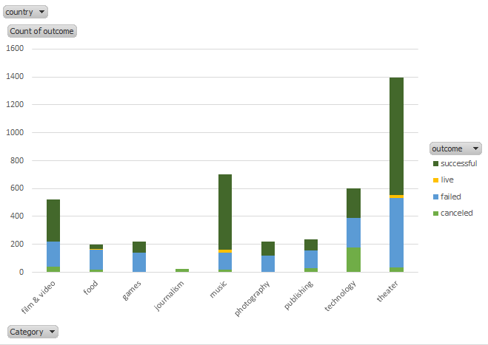

* 1. Theater, Music, Technology, and Film/Video are the four types of projects most commonly funded on Kickstarter (respectively)

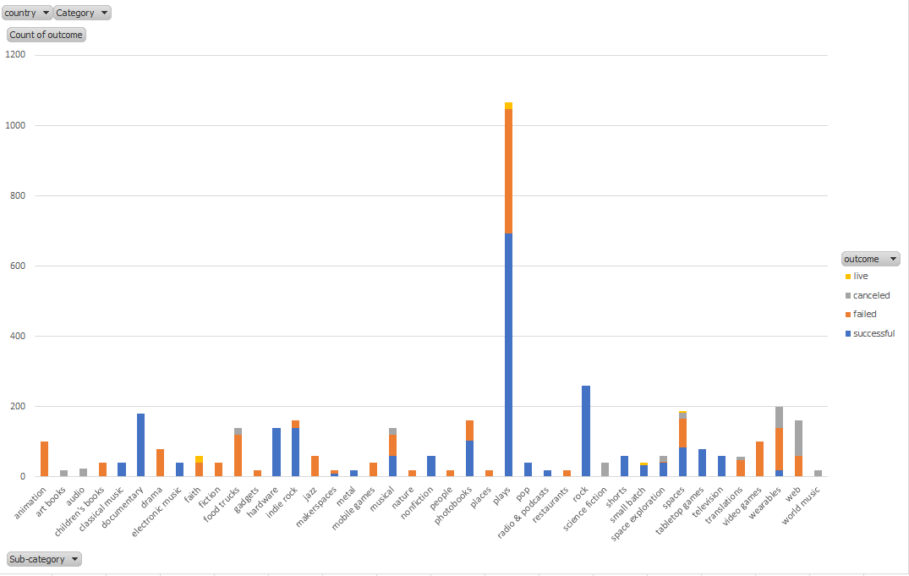

* 1. The most commonly funded sub-category of project is plays.

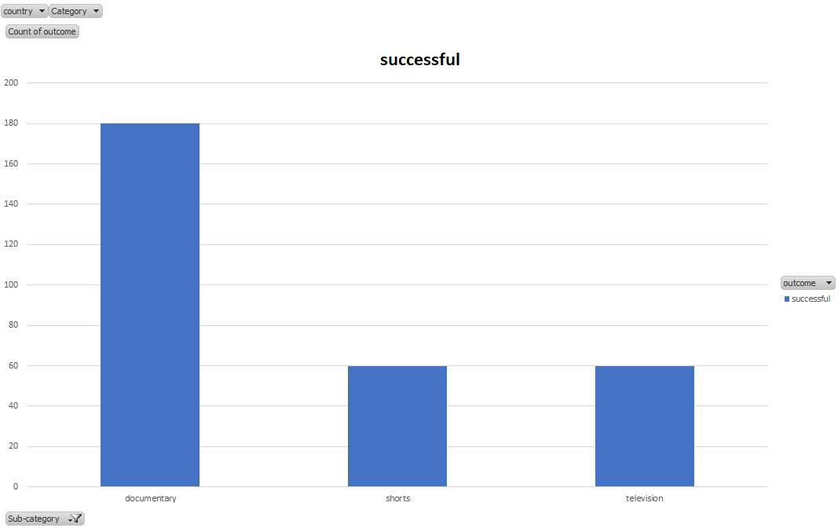

* 1. All documentary films, short films, and television projects that raise funds through Kickstarter have been successful.

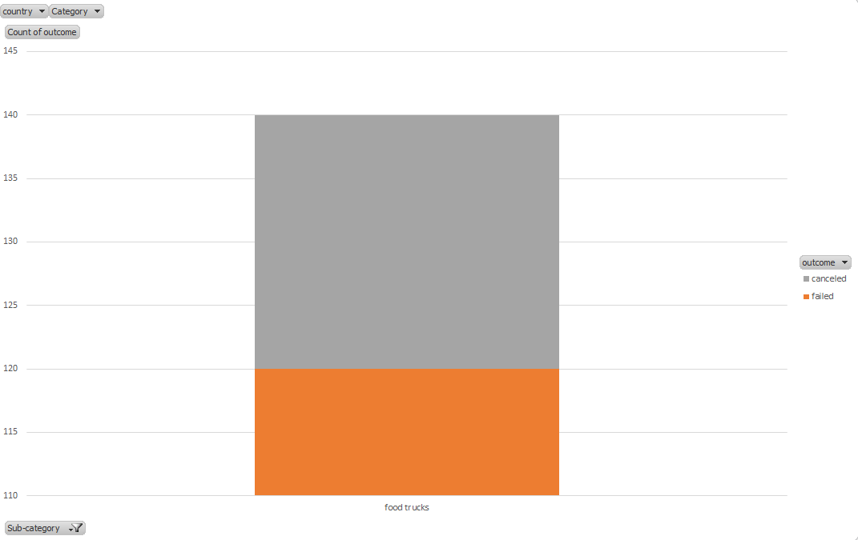

* 1. Bonus: Don’t try to raise funds for a food truck through Kickstarter

1. What are some of the limitations of this dataset?



* 1. I’ve seen a few of the projects incorrectly categorized. So there is user error (the person doing the fund raising) and/or because these projects did not fit into categories allowed fundraising through Kickstarter.

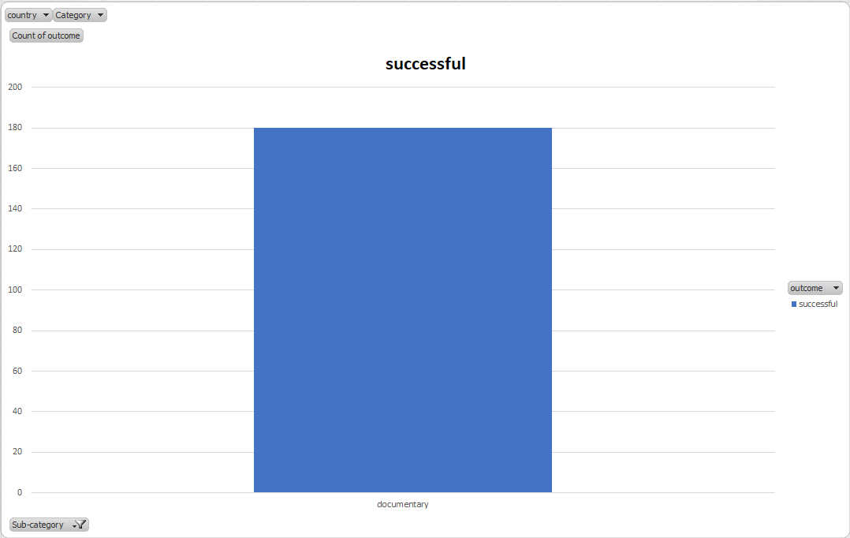

* 1. This data doesn’t take into account outside factors such as marketing, social media presence, etc.… Some of the people fundraising on Kickstarter may be better at promoting their project. Simply putting up a Kickstarter page to fund a documentary film will not guarantee it will be successful, although the data implies it will.

1. What are some other possible tables/graphs that we could create?
   1. Whether or not being chosen as a “Project We Love” (Staff Pick) has any impact on the success rate of fundraising.

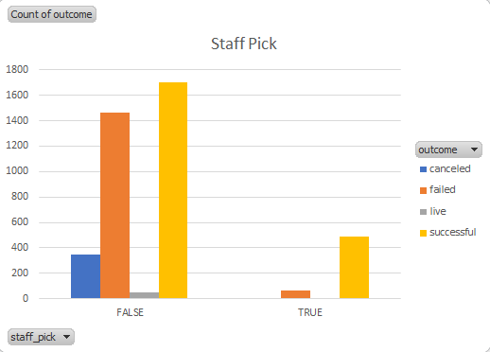

* + 1. It appears that the success rate of a Kickstarter project is significantly higher if it is highlighted as a “Project We Love”
  1. When is the time of the year that most fundraisers start their projects.

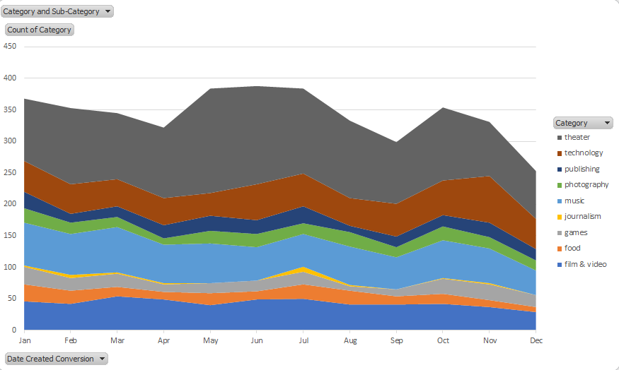

* + 1. Overall, most Kickstarter projects start fundraising in May – July, smaller peaks in January and October with the slowest time of the year in December.

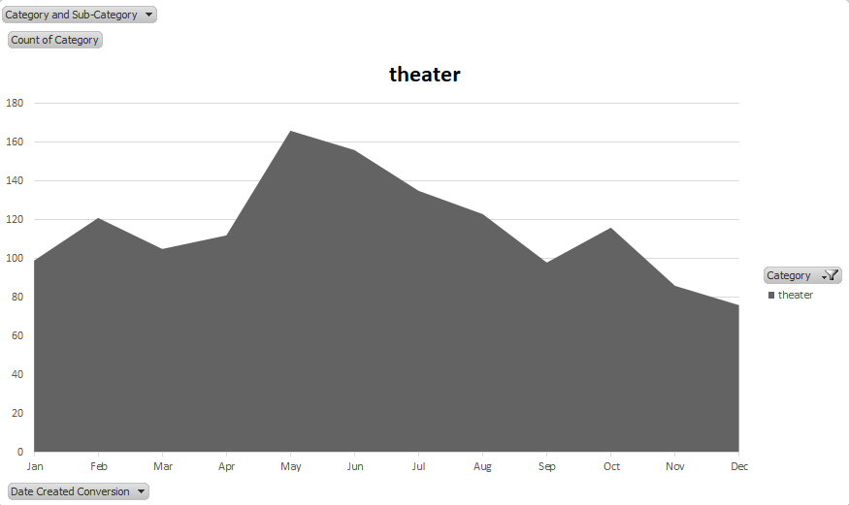

* + 1. There is a filter on this pivot chart to change the type of project to see the seasonality of each type of project. The overall data is skewed toward theater fundraising, which is overwhelmingly the type of project funded through Kickstarter.

